***PROJECT-2***

**PERSONAL PORTFOLIO**

**Table of contents:**

* Portfolio Page
* Experience Page
* Contact Page
* Output

**Portfolio Page**

**Description:**

The portfolio page serves as a visual representation of my work, displaying various projects I have undertaken. Each project is accompanied by a brief description highlighting its key features and technologies used.

**Implementation:**

- HTML Structure:The page is structured using HTML5 elements like `<header>`, `<main>`, and `<footer>`.

- CSS Styling: CSS is used to enhance the visual appeal of the portfolio, including layout design, color schemes, and typography.

- Icons: Icons are incorporated using libraries like Font Awesome to provide visual cues and improve user experience.

**Challenges Faced:**

- **Responsive Design**: Ensuring the portfolio looks good on different screen sizes and devices was a challenge. Media queries were used to adapt the layout for various resolutions.

- **Cross-Browser Compatibility**: Ensuring consistency in appearance across different web browsers required thorough testing and tweaking of CSS properties.

- **Optimizing Load Times:** To prevent slow loading times, image sizes were optimized, and CSS and JavaScript files were minified.

**Experience Page**

**Description:**

The experience page provides an overview of my professional journey, highlighting key roles, responsibilities, and achievements.

**Implementation:**

- HTML Structure: The page is structured using semantic HTML elements like `<section>`, `<article>`, and `<ul>`.

- CSS Styling: CSS is used to style the content, including typography, spacing, and alignment.

- Icons: Icons are used to represent different industries, job roles, and skills, making the information visually appealing and easy to comprehend.

**Challenges Faced:**

- **Content Organization**: Presenting a comprehensive yet concise overview of my experience posed a challenge. Careful selection and structuring of information were required.

- **Visual Hierarchy:** Balancing the visual hierarchy to draw attention to key points while maintaining readability was crucial. CSS techniques like font sizes, colors, and spacing were used to achieve this.

- **Accessibility**: Ensuring the content is accessible to users with disabilities required attention to contrast ratios, focus states, and semantic HTML markup.

**Contact Page**

**Description:**

The contact page provides visitors with various means to get in touch with me, including a contact form, email address, and social media links.

**Implementation:**

- HTML Structure: The page includes a contact form created using HTML `<form>` elements for input fields and a submit button.

- CSS Styling: CSS is used to style the form elements, ensuring they are visually appealing and easy to interact with.

- Icons: Icons are used to represent different contact methods, such as email, phone, and social media platforms.

**Challenges Faced:**

- **Form Validation**: Implementing client-side form validation to ensure users provide valid input without relying solely on server-side validation presented a challenge. JavaScript was used to validate form fields before submission.

- **Spam Protection**: Implementing measures to prevent spam submissions through the contact form required the use of CAPTCHA or other anti-spam techniques.

**- Responsive Design**: Ensuring the contact form remains usable and accessible on various devices and screen sizes was a priority. CSS techniques like flexbox and media queries were utilized for responsive design.

This documentation provides an overview of the structure, implementation, and challenges faced during the development of my personal portfolio website. Thank you for taking the time to explore it!

**OUTPUTS:**

**Portfolio Page:**

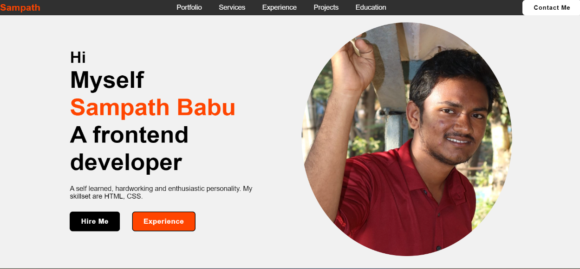

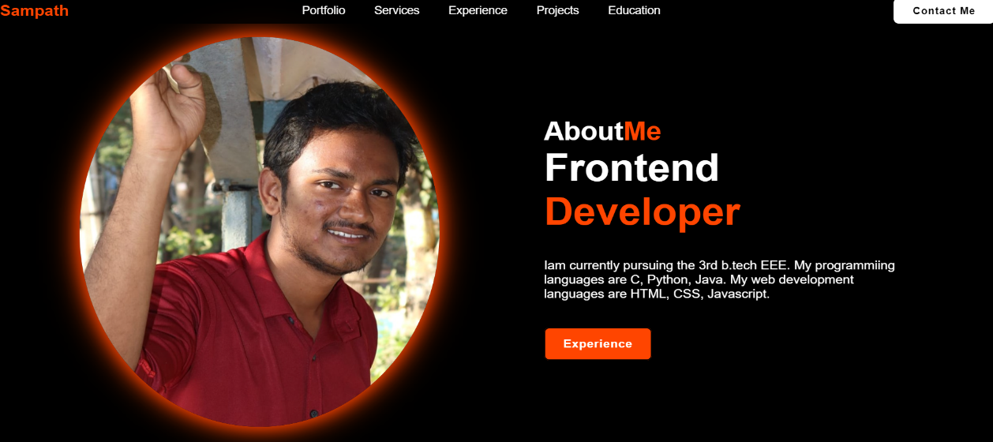

**Experience Page:**

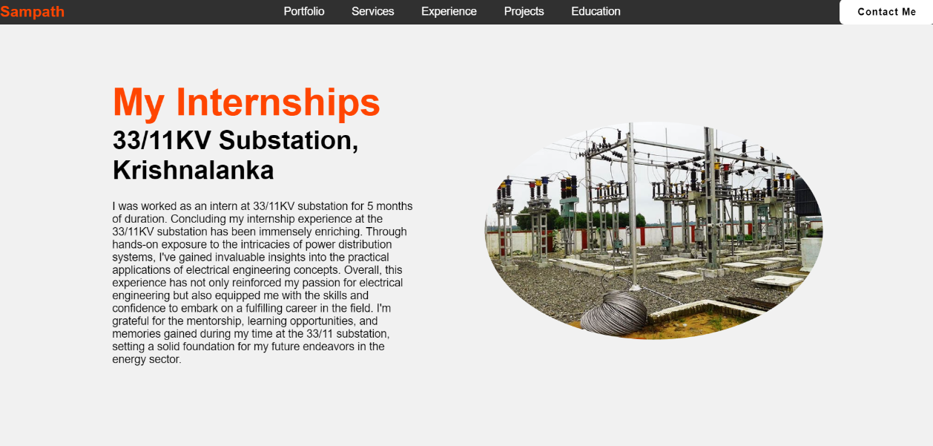

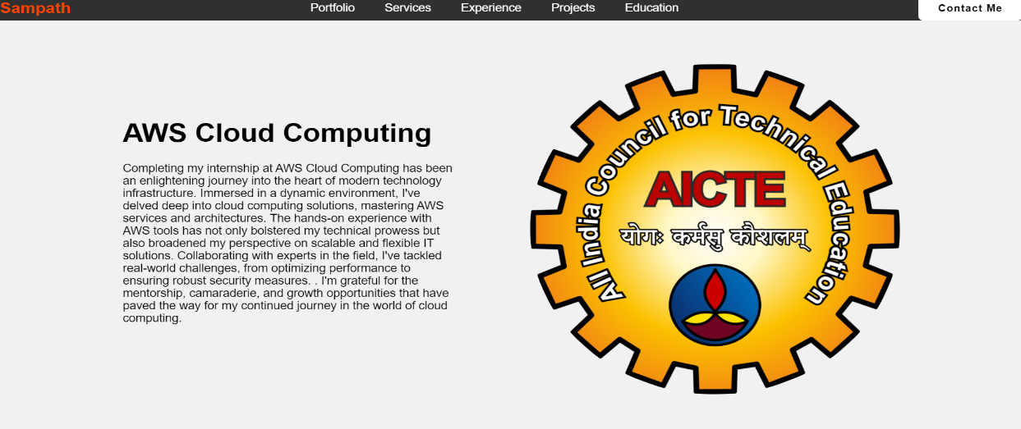

**Contact Page:**



